Chapter 3 – Methodology
This capstone uses a development methodology based on the actual Graduate School setting. The current setup is still largely manual and spread across AIMS, spreadsheets, protocol forms, paper records, and email coordination. The confirmed notes with Sir Eddie De Paula show that admissions begin in AIMS, enrollment monitoring depends on files such as the AC-Student-Monitoring template, LOA and withdrawal are handled through email, and reports such as subject needs, graduating student lists, LOA monitoring, and residency tracking still require manual checking and consolidation. Because of this, the prototype must be built from validated Graduate School records and approved process details, not assumptions.
At this stage of the study, the problem statement, AS-IS analysis, and requirements have already been established in the earlier chapter. For this reason, Chapter 3 focuses on turning those validated findings into a workable prototype. The development flow used in this study has four parts: TO-BE BPMN refinement and process design (to be accomplished during the second phase of capstone, CAP-IT1), Sprint 0 for MVP and planning, sprint-based prototype development, and evaluation. This sequence keeps the work tied to the approved Graduate School scope and makes the prototype easier to review and improve.
For implementation, the project uses an Agile approach through Scrum. Scrum fits this project because the Graduate School processes are detailed and role-based, and several monitoring needs became clearer only after the BPMNs, forms, and signed notes were reviewed. The notes confirmed that the Academic Coordinator needs both per-student and consolidated subject views, that AY and semester taken are important fields, and that reports such as LOA monitoring and residency tracking are still difficult to prepare from separate records. A sprint-based approach allows the group to validate one part at a time, gather feedback, and revise the prototype before moving to the next set of functions.

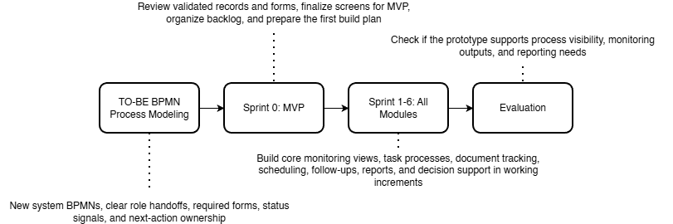

Figure 5.1 Methodology Flow of the Study with Scrum-Based Prototype Development
In this project, the capstone group will apply Scrum in a simple and practical way. One member will act as the Product Owner by organizing the backlog based on the validated Graduate School requirements. One member will act as the Scrum Master by keeping the sprint schedule, meetings, and follow-up actions on track. The remaining members will act as Developers by designing, building, and testing the prototype. Within Sprint 1 to n, the Scrum cycle is repeated through sprint planning, design, build, sprint review, and retrospective so that each increment can be improved before the next one begins.
The development process begins with TO-BE BPMN refinement and process design. In this stage, the group refines the Graduate School-only BPMNs so that the proposed flow matches the approved scope of the project. This includes clarifying who performs each step, what form or record is involved, what status signal is captured, and who owns the next action. This is important because the confirmed notes identify specific role ownership. Staff handle loading and support, the Academic Coordinator handles advising and most decisions, the Research Class Coordinator manages research-related monitoring, and the Dean approves LOA and withdrawal.
After that, the group moves to Sprint 0: MVP and Planning. During this stage, the team reviews the validated Graduate School records, including the AC-Student-Monitoring template, the Student-Research-Monitoring sheet, and the Graduate School Research Protocol. The group then prepares the first prototype screens, checks if the user flow matches the BPMNs, and organizes the backlog for the first coded sprint. This step is important because the prototype must match the actual Graduate School process, forms, and records before coding begins.
The next stage is Sprint 1 to 6: Incremental Prototype Development. In these sprints, the team builds the prototype in working increments. The early sprints focus on the most basic needs first, especially Student Progress Management and Case Status and Action Tracking because these are needed to make student status visible. Later sprints add scheduling, follow-up records, dashboards, reports, and the implementation of Retrieval-Augmented Generation (RAG) via NotebookLM. This order fits the confirmed Graduate School needs, which include one consolidated view of student status, clearer ownership of next actions, document evidence tracking, LOA monitoring, residency tracking, and reports for subject needs and graduating student lists. Each sprint goes through planning, design, build, review, and retrospective so the team can improve the next increment based on feedback.
The last stage is Evaluation. In this stage, the group checks whether the prototype supports the agreed monitoring outputs, process visibility, and reporting needs of the Graduate School. The evaluation focuses on whether the prototype helps users see where the student is now, what is pending, who owns the next action, and which reports can be generated from the structured records. This is directly tied to the confirmed Graduate School needs, especially subject needs, graduating student lists, LOA monitoring, and residency tracking.
This methodology also matches the scope of the project. The signed notes confirm that the platform should remain a monitoring and support layer only. It should not replace AIMS admissions, Registrar records, or Accounting processes. Instead, it should capture only the allowed status signals, evidence, handoffs, and timestamps needed by the Graduate School for monitoring, follow-up, and reporting. Because of this, the methodology focuses on refining the approved process flow, validating the interface through an MVP, and building only the functions that match the confirmed scope.

3.1 Proposed System Development
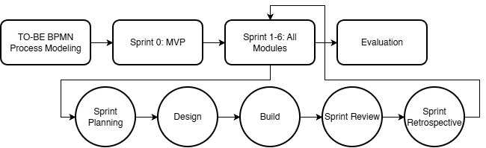

Figure 5.2 Proposed System Development Approach
The proposed platform is a Graduate School monitoring and processing platform designed to improve visibility of student progress and support Graduate School follow-up and reporting. It brings together allowed status signals, handoffs, required evidence, schedule events, and timestamps into one connected view so that Graduate School users can monitor cases without repeatedly checking separate spreadsheets, forms, and email threads.
The platform is intended for Graduate School use only and focuses on Graduate School-owned monitoring and processing. It covers admission handoff monitoring, enrollment monitoring, coursework and study plan tracking, LOA and readmission, thesis and dissertation milestones, practicum where confirmed, withdrawal, and graduation endorsement on the Graduate School side. These areas are directly supported by the confirmed notes, which identify subject needs, AY and semester taken, completion markers, LOA tracking, residency tracking, document evidence, and graduation candidate review as important monitoring needs.
The main users of the platform are Graduate School office staff, the Academic Coordinator, the Research Coordinator, the Dean, advisers and panel roles where applicable, and graduate students for limited progress viewing. The confirmed notes show that staff handle loading and support, the Academic Coordinator handles advising and most decisions, the Research Class Coordinator handles research-related monitoring, and the Dean approves LOA and withdrawal and receives reports. For this reason, the platform is designed around these Graduate School roles rather than around a general student information platform.
The prototype will first be developed as an MVP so the group can validate the screens, flow, and user actions before coding. After that, the coded prototype will be built in sprint-based increments. This allows the group to check that the screens match the BPMNs, the user roles, and the actual Graduate School records before more functions are added.
The platform organizes its main functions according to the conceptual framework modules. Student Progress Management keeps the student’s stage, status markers, curriculum tag, AY and semester taken, and completion indicators. Case Status and Action Tracking shows who owns the next action and what decision moved the case to its current state. Defense Scheduling Management records scheduling requests, availability, confirmations, and reschedules. Case Monitoring and Follow-Up supports alerts, watchlists, and follow-up records for delayed or incomplete cases. Policy and Case Guidance provides guided summaries, completion rate analysis, and next-step prompts by using Retrieval-Augmented Generation (RAG) via NotebookLM to access approved records, uploaded document repository contents, and system-computed indicators. Reports and Dashboards generate outputs such as subject needs lists, graduating student lists, LOA monitoring, residency tracking, and completion summaries.
The platform uses existing Graduate School records as its basis. For coursework and study plan monitoring, it uses fields grounded in the AC-Student-Monitoring template, especially curriculum alignment, taken or not taken status, and AY and semester taken. For research stages, it uses the Graduate School Research Protocol forms and rules, such as Form 4 for proposal or final defense endorsement, Form 5 and Form 5.1 for proposal comments and technical review, Form 5.2 for ethics review, and Forms 6, 7, 9, and 10 for final defense, manuscript finalization, and completion evidence. The protocol also provides timing rules, such as the two-week lead time, the 14-day rule, and the five-day public defense filing rule, which can be reflected in the prototype’s scheduling and follow-up logic.
The platform is not intended to replace official institutional systems. The confirmed notes state that admissions remain in AIMS, grades and official academic records remain on the Registrar side, and Accounting processes must not be replaced. The prototype therefore captures only the monitoring signals and process records that the Graduate School is allowed to use, such as status tags, handoffs, evidence checkpoints, and timestamps. This keeps the project within its approved scope and makes the proposed platform different from a full school information system.
Development under Scrum will move from the most basic monitoring needs to the more advanced outputs. The first coded sprints focus on Student Progress Management and Case Status and Action Tracking because two are the minimum functions needed to make status visible. Later sprints add scheduling, follow-up records, dashboards, reports, and the implementation of RAG via NotebookLM. This order fits the confirmed Graduate School need for a consolidated view first, followed by better reporting and guided next actions after the core records are in place.

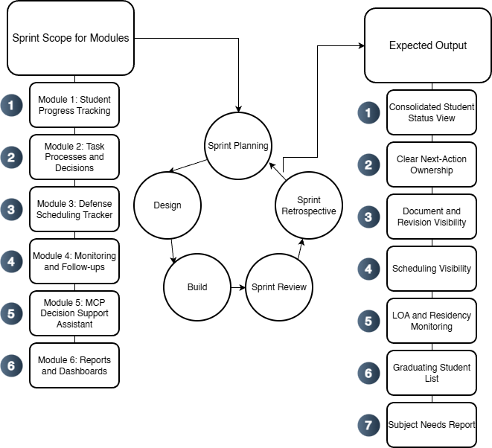

Figure 5.3. Proposed System Development Overview Using Agile Scrum
Figure 5.3 shows how the proposed platform is developed per module using a Scrum-based cycle. The validated Graduate School records serve as the basis of development. For each sprint, the team selects one module or a set of related functions, then goes through sprint planning, design, build, sprint review, and retrospective. Each sprint produces a working increment, and the cycle is then repeated for the next module. This keeps the development process aligned with the approved Graduate School scope while allowing the prototype to improve in small, reviewable increments.

3.2 Phases
Section 3.2 presents the project’s specification phases, which translate the Graduate School’s operational reality (task processing, protocol forms, records, and role handoffs) into implementable requirements. These phases are not the term-by-term schedule (which is presented later in the Workplan). Instead, the phases explain the sequence used to ensure that monitoring and decision support are built on clear definitions of completion, clear ownership of next actions, and feasible event capture, so dashboards, queues, and prescriptive recommendations do not rely on inconsistent or disputed status labels.
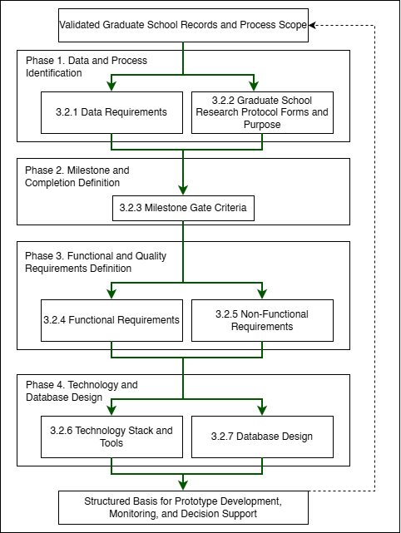

Figure 5.4. Specification Phases for the Proposed Graduate School Monitoring and Decision Support Platform
To keep the specification and requirements organized in an ordered flow:
- 3.2.1 Data Requirements identifies the minimum lifecycle and research data that must be captured, who provides it, where it currently resides (AS-IS), and why it is needed for monitoring and decision support.
- 3.2.2 Graduate School Research Protocol Forms and Purpose documents the official thesis/dissertation forms and clarifies what each form represents operationally, so form submissions and approvals can be captured as traceable process events.
- 3.2.3 Milestone Gate Criteria defines the definition of completion per gate (entry criteria, required evidence, decision outcomes, and exit criteria), and aligns these gates with the TO-BE process so completion and readiness checks become measurable and consistent.
- 3.2.4 to 3.2.5 Functional and Non-Functional Requirements convert validated processes and data needs into system capabilities and quality constraints (for example RBAC, auditability, usability, and reliability).
- 3.2.6 Technology Stack and Tools specifies the development tools and implementation approach aligned to the system scope and boundaries (monitoring and decision support layer, not an institutional record system replacement), including support for prescriptive decision support outputs and optional controlled LLM use.
- 3.2.7 Database Design defines how the platform stores lifecycle and milestone evidence as structured records, including core tables, key relationships, validation rules, the grouped ERD (A to G), and the derived indicators used for descriptive monitoring and prescriptive decision support recommendations.

3.2.1 Data Requirements
Data Category | Key Fields | Primary Source Role | Existing System (AS-IS) | Use for Monitoring and Analytics
Student identity + program profile | Student name; ID number; program/track; year level; AY entry | Staff/Admin; Student (for verification) | Student Monitoring Excel Sheet (AC-STUDENT-MONITORING-Template.xlsx) | Baseline linking key across coursework + research monitoring; supports cohort grouping and drill-down views.
Coursework / enrollment monitoring | AY entry; subjects/codes; unit totals; standing/progress markers | Staff/Admin; Coordinator | Student Monitoring Excel Sheet (AC-STUDENT-MONITORING-Template.xlsx) | Enables “coursework-to-research readiness” monitoring where applicable.
Admission monitoring (status signals) | Requirements submitted date; application status; handoff confirmation | Admission Office; Graduate School Staff | AIMS + email-based handoff | Completes lifecycle coverage from admission without replacing AIMS.
Enrollment confirmation / term activation | Enrollment confirmation status per term; timestamp; active/inactive/stop-start signals | Graduate School Staff; Academic Coordinator | Email-based triggers + enrollment platform status | Prevents “gap in enrollment” visibility; supports continuity monitoring.
Curriculum tagging and study plan generation | Curriculum ID/version; student–curriculum tag date; required subjects; planned AY/Sem mapping | Academic Coordinator; Staff | Curriculum records + Student Monitoring Excel Sheet (AC-STUDENT-MONITORING-Template.xlsx) / study plan form | Enables per-student course audit and cohort-based monitoring for offerings and readiness.
Class offerings decision-support inputs | Eligible student counts per subject; pending prerequisites; planned offerings summary | Academic Coordinator | Student Monitoring Excel Sheet (AC-STUDENT-MONITORING-Template.xlsx) + curriculum mapping outputs | Supports “subjects to offer next semester” decision support.
LOA application monitoring | LOA request date; approval status; LOA start/end; LOA expiry marker | Graduate School Staff; Dean | Email-based routing + LOA tracking record | Adds visibility and escalation signals for LOA.
Readmission monitoring | Readmission request date; decision outcome; return term; conditions (if any) | Graduate School Staff | Email/manual records | Tracks re-entry pathway after LOA; supports continuity/readiness checks.
Residency monitoring signals | Residency clock start; pause/resume markers; nearing limit flags | Graduate School Staff/Coordinator | Derived monitoring record (policy-confirmed parameters) | Supports residency monitoring without changing policy.
Research case profile | AY first enrolled in thesis/dissertation; current AY; semester; program; adviser | Staff/Admin; Coordinator | Thesis Student Research Monitoring Sheet (Student-Research-Monitoring.xlsx) | Timeline anchor for time-in-stage, residency indicators, and exception tracking.
Adviser assignment + eligibility constraints | Adviser name; appointment status; date appointed; adviser load indicator | Research leadership/Admin | Research Protocol (Form 3 / 3.1) + spreadsheet reflections | Supports routing/accountability and adviser load monitoring.
Title defense events | Endorsement; schedule date; approved title; decision outcome | Student; Coordinator; Panel Chair; Admin | Thesis Student Research Monitoring Sheet (Student-Research-Monitoring.xlsx) (Forms 1–2) | Captures early bottlenecks (endorsement + scheduling).
Proposal defense readiness + gate requirements | Endorsement; schedule; technical clearance; statistician consult (conditional) | Student; Adviser; Statistician; Admin | Thesis Student Research Monitoring Sheet (Student-Research-Monitoring.xlsx) (Forms 4, 4.1, 5) | Detects readiness blocks and scheduling bottlenecks.
Ethics review and clearance | Ethics submission; clearance date/status | Student; Ethics Office/Admin | Thesis Student Research Monitoring Sheet (Student-Research-Monitoring.xlsx) (Form 5.2) | Enables stop-the-clock/restart tracking around ethics review.
Final defense events | Endorsement; schedule; outcome (pass/minor/major); re-defense status | Student; Adviser; Panel; Admin | Thesis Student Research Monitoring Sheet (Student-Research-Monitoring.xlsx) (Forms 6–8) | Captures revision cycles/decision states for bottleneck identification.
Public defense + publication/completion tagging | Public defense schedule; Turnitin cert; editor cert; final approval sheet; publication step | Student; Adviser; Admin | Thesis Student Research Monitoring Sheet (Student-Research-Monitoring.xlsx) (Forms 9–10) + Turnitin step | Converts endgame requirements into a traceable checklist; supports stuck-case detection.
Scheduling state and constraints | Proposed/confirmed dates; reschedules; mode; venue reservation | Admin/Staff; Panel Chair; Student | Email-based coordination + protocol steps | Measures scheduling cycle time and repeated back-and-forth.
Decision records + comment consolidation | Outcomes; consolidated comment sheet; approvals/release certs | Panel Chair; Panel Members; Adviser | Research Protocol (Form 5 consolidation; Form 5.1; Form 6/7) | Reduces version confusion; strengthens traceability/accountability.
Workload and operational queues | Pending endorsements; overdue items; aging cases; adviser/panel load counts | Admin; Coordinator; Leadership | Derived from milestone events + role assignments | Core decision-support layer for escalation and workload balancing.
Authority + audit signals | RBAC; access boundaries; change logs; retention rules | Admin | Thesis Student Research Monitoring Sheet (Student-Research-Monitoring.xlsx) (Forms 1–2) | Supports privacy-aligned handling and auditability for sensitive documents.
Practicum/OJT monitoring (if applicable) | Required hours; schedule; completion status; evidence checklist | Program Coordinator | Manual logs / certificates (MOA/certifications) | Included only when the program requires it; treated as completion signals.
Withdrawal monitoring | Withdrawal request/confirmation; effective term; reason (if allowed) | Graduate School Staff; Dean | Email/manual records | Tracks stop pathway formally for attrition reporting where allowed.
Graduation endorsement monitoring (Graduate School side) | Endorsed-to-graduate date; requirements complete flag; evidence checklist | Graduate School Staff; Academic Coordinator | Endorsed list + manual checklist | Supports graduating list preparation without replacing registrar processing.

Table 5. Data to be collected and sources
Table 5 summarizes the operational data that must be captured to support lifecycle monitoring and decision support, including who provides each data element, where it currently resides (e.g., spreadsheets, email routing, and protocol forms), and what monitoring purpose it serves. In current practice, evidence of progress is distributed across spreadsheets and email-based coordination, while the Graduate School Research Protocol defines the official events, forms, decision gates, and role handoffs that must be tracked. Accordingly, the data scope emphasizes lifecycle status signals, milestone events, decision records, scheduling states, document/version evidence, and workload indicators needed to answer monitoring questions such as: where the student is now, what is pending, who owns the next action, and where delays occur.

3.2.2 Milestone Gate Criteria
Milestone | Entry Criteria | Required Evidence | Decision outcomes | Exit Criteria | Role
Admission Handoff Confirmed | Student has submitted requirements and admission status signal is available for handoff | AIMS status + handoff confirmation (email/record) | Accepted for onboarding / For completion / Not accepted | Handoff recorded; student is visible to Graduate School for onboarding and monitoring | Admission Office (status) + Graduate School Staff (handoff receipt)
Student Account + Program Onboarding Completed | Admission handoff confirmed | Enrollment platform account created; onboarding checklist (if used) | Activated / Returned for correction | Student account activated; student is tagged to program context for monitoring | Graduate School Staff / Academic Coordinator
Curriculum Tagged + Study Plan Generated | Student account exists; curriculum list/version exists | Curriculum ID/version record; student–curriculum tag record; generated study plan | Tagged / Corrected / Deferred | Student is linked to a curriculum; study plan (required subjects) is generated and viewable | Academic Coordinator
Term Enrollment Confirmed | Student is eligible to enroll for the term (per Graduate School) | Enrollment confirmation record (email trigger / enrollment platform status) | Confirmed / On hold / Not confirmed | Term status is recorded as active/inactive; monitoring continuity is visible (no “gap”) | Graduate School Staff / Academic Coordinator
Course Audit Updated | Term results/standing signals are available to be mirrored as monitoring indicators (without replacing grade encoding) | Monitoring sheet update (course completion/INC marker); supporting reference to official record where permitted | Updated / Pending update / Exception flagged | Course audit reflects latest completion/INC markers and remaining requirements for readiness checks | Academic Coordinator
Class Offerings Planning Completed | Curriculum + course audit data are available to compute eligible counts | Aggregated eligibility counts per subject; planned offerings summary | Approved offerings plan / Revised / Deferred | “Subjects to offer next semester” output is generated and recorded for term planning | Academic Coordinator
LOA Approved and Recorded | Student submits LOA request; case is active | LOA request record + approval decision + effective LOA start/end dates | Approved / Denied / Returned for completion | LOA status is recorded with effective period and expiry marker; student marked stop-start for monitoring | Dean (approval) + Graduate School Staff (recording)
Readmission Approved and Recorded | LOA period ended or readmission requested | Readmission request record + decision outcome + effective return term | Approved / Denied / Returned for completion | Readmission status recorded; student marked active for the return term | Graduate School Staff / Dean (as applicable)
Research Case Created | Readiness to start thesis/dissertation is confirmed (program-dependent) | Research case profile created (type, first enrolled AY, adviser pending/assigned) | Created / Deferred | Research case exists and becomes the basis for milestone event tracking | Research Coordinator / Staff
Adviser Designation Completed | Research case exists; adviser nomination is initiated | Research Protocol Forms 3 / 3.1 (adviser designation and appointment) and recorded adviser assignment | Appointed / Returned / Not appointed | Adviser assignment is recorded with date and ownership routing can begin | Research Leadership / Research Coordinator
Title Defense Completed | Adviser designation completed; title defense request endorsed | Research Protocol Forms 1–2 (title defense application + outcome); schedule record (if used) | Approved title / Returned for revision / Not approved | Approved title is recorded; status advances to proposal preparation stage | Panel Chair (decision) + Research Coordinator (recording)
Proposal Defense Completed | Title approved; proposal defense endorsed and scheduled | Research Protocol Forms 4, 4.1 (if applicable), 5 + schedule record + outcome/comments record | Passed / Revisions required / Re-defense required | Proposal defense outcome recorded; required changes captured as the authoritative revision basis | Panel Chair + Research Coordinator
Ethics Clearance Recorded | Proposal stage requires ethics review/clearance | Research Protocol Form 5.2 (ethics submission/clearance) | Cleared / Returned / Not cleared | Ethics clearance status and date are recorded; case may proceed to data collection/writing milestones | Ethics Office (clearance) + Research Coordinator (recording)
Final Defense Completed | Final defense endorsed and scheduled | Research Protocol Forms 6–8 (final defense comments/evaluation/settlement where applicable) + schedule/outcome record | Passed / Minor revisions / Major revisions / Re-defense | Final defense outcome recorded; revision pathway is explicit (minor/major/re-defense) | Panel Chair + Research Coordinator
Completion Evidence Verified | Final defense outcome permits completion processing | Research Protocol Forms 9–10 + Turnitin certificate + editor certification + approval sheet (as applicable) | Verified complete / Missing requirements / Returned | All required completion evidence is recorded as complete; case is eligible for GS endorsement | Graduate School Staff / Research Coordinator
Withdrawal Confirmed and Recorded | Student requests withdrawal; case is active | Withdrawal request/confirmation record (email/manual) | Approved / Denied / Returned | Withdrawal status recorded; monitoring stops with an auditable exit reason category (if allowed) | Dean + Graduate School Staff
Graduation Endorsement Completed | Completion evidence verified; no active stop-start/withdrawal | Endorsed-to-graduate list + requirements checklist (GS-side) | Endorsed / On hold / Returned for completion | Graduate School endorsement status recorded; endorsement list is prepared and handed off (registrar remains out-of-scope) | Graduate School Staff + Academic Coordinator / Dean

Table 6. Milestone Gate Criteria explaining definition of completion
Table 6 represents the “definition of completion” for lifecycle and research progress monitoring. It specifies the minimum entry criteria, required evidence, decision outcomes, and exit criteria for each gate so that process states are interpretable across roles and suitable for consistent monitoring (e.g., pending queues, aging/time-in-stage, and readiness checks). This reduces ambiguity in status labeling and supports decision support by clarifying what must be true before a case can advance and what evidence confirms completion.

3.2.3 Functional Requirements
Category | Description
Curriculum and Study Plan Management | Load and maintain program curricula, tag a student to the correct curriculum, generate a per-student study plan, and show required subjects with AY and semester taken. Record subject completion date and status for course audit.
Enrollment and Coursework Monitoring | Track enrollment confirmation and course audit status. Provide a student view of the next semester schedule where allowed, and a coordinator view of student eligibility and remaining requirements without replacing official grade encoding.
Class Offerings Decision Support | Generate outputs that help the Academic Coordinator decide what subjects to offer next semester, such as counts of eligible students per subject, pending requirements, and a planned offerings summary.
LOA and Readmission Monitoring | Track LOA request status, approval, and effective LOA period. Track residency pause and readmission status, and generate LOA monitoring views for staff and coordinators.
Thesis and Dissertation Monitoring | Track adviser designation, title defense, proposal defense, final defense, revision cycles, manuscript finalization, and required certifications or documents. Record status, assigned role, and time on stage.
Practicum or OJT Tracking (Program-dependent) | Where required by the program, track required hours, schedule, and uploaded evidence such as MOA or certifications as completion signals. Exclude this if the program does not require it.
Withdrawal and Graduation Monitoring | Track withdrawal confirmation status and Graduate School graduation endorsement status. Generate graduating list outputs based on completion evidence without replacing Registrar processing.
Task Processing and Task Queues | Provide role-based task queues for submissions, endorsements, approvals, and decisions. Show who owns the next action across lifecycle stages.
Decision Recording | Record decision outcomes such as approve, revise, or return, together with the next required action and closure evidence for each milestone step.
Document Tracking | Maintain a required document checklist for each stage, track document versions, and record consolidated comments or decision records.
Scheduling Tracking | Record defense request, availability, and schedule outcome. Log reschedules and cancellations as monitoring signals.
Dashboards and Reports | Generate counts per stage, pending queues, aging or time in stage, LOA counts, course audit readiness, adviser or panel counts where applicable, and residency, completion, or attrition outputs based on validated definitions.
Alerts and Intervention Tracking | Detect threshold breaches such as long time in stage, LOA nearing expiry, or residency nearing limits. Notify the correct roles and log intervention actions with closure evidence.
Audit Trail | Log actions, decisions, and changes in definitions or process settings to support accountability.

Table 7. Functional Requirements of the modules
Table 7 summarizes the functional requirements of the proposed platform. These requirements come from the main Graduate School monitoring and processing needs, including scattered records, unclear next-action ownership, scheduling delays, revision tracking problems, and missing or inconsistent timestamps.

3.2.4 Non-Functional Requirements
Category | Description
Security | Enforce role-based access control, strong authentication, secure session handling, and controlled privileges for higher-level users.
Privacy | Limit access to sensitive evaluation records, log access where needed, and handle data according to approved privacy boundaries (Datu, 2022).
Auditability | Keep append-only logs for key actions such as submissions, decisions, approvals, routing, and definition changes. Each log entry must show the actor, timestamp, and outcome.
Usability | Provide role-based dashboards and task queues, clear status labels, low encoding effort for staff, and consistent terms across modules.
Reliability | Apply data checks, validate required fields, support backup and recovery, and generate consistent timestamps for monitoring and reporting.
Maintainability | Allow milestone definitions, checklists, and process rules to be updated where possible without changing code, while keeping a controlled change process with logs.
Performance | Keep dashboard queries responsive, support efficient search and filtering, and handle document and log storage in a manageable way.
Interoperability | Allow export of reports and structured datasets. Allow integration or data exchange with institutional systems only where permitted by ownership and privacy rules.

Table 8. Non-Functional Requirements of the modules
Table 8 summarizes the non-functional requirements of the proposed platform. These requirements help make the system usable, dependable, and appropriate for Graduate School use. The platform also supports privacy, accountability, and adoption in an educational setting (Tanate-Lazo, 2021; Sancon, 2023).

3.2.5 Technology Stack and Tools
The proposed platform is a web-based graduate student lifecycle monitoring and decision-support system for Graduate School operations. The technology stack is selected to support the platform’s current core application modules: (1) Student Progress Management, (2) Case Status and Action Tracking, (3) Defense Scheduling Management, (4) Case Monitoring and Follow Up, (5) Analytics and Decision Support, (6) Policy and Case Guidance, and (7) Reporting and Dashboards. These modules are supported by cross-cutting platform capabilities for User and Access Management and Audit Trail and Compliance Logging to maintain secure access, traceability, and accountability across the system. The platform follows a web architecture that uses React and TypeScript for the frontend, Tailwind CSS for interface styling, Node.js and Express.js for backend services, MySQL and Prisma for data management, and JWT for authentication. This stack supports structured monitoring views, role-based task queues, scheduling records, dashboards, analytics outputs, and traceable activity logs within one system.
For analytics and reporting, the platform uses Chart.js to present counts, trends, queue conditions, and time-based monitoring indicators through dashboard views. GitHub is used for source control, issue tracking, and sprint management. Figma is used for interface mockups and clickable prototypes, while draw.io and dbdiagram.io are used for process diagrams, architecture diagrams, and database design.
For deployment and secure web access, Cloudflare is used for DNS management, HTTPS, SSL/TLS encryption, edge security, and content delivery. This supports secure access to the deployed system and helps protect the application during testing and demonstration.
For policy and case guidance, the proposed system implements Retrieval-Augmented Generation (RAG). The RAG pipeline uses LangChain.js for document retrieval orchestration, OpenAI API for embeddings and response generation, and ChromaDB as the vector database for storing and retrieving indexed policy documents, forms, guidelines, and case references. This setup allows the assistant to retrieve relevant institutional documents first and then generate grounded summaries, policy-based guidance, and suggested next steps. The assistant supports monitoring and administrative review only. Final decisions remain with authorized personnel.
The selected tools are feasible within a capstone timeline while keeping the architecture scalable, maintainable, and aligned with the project’s approved scope as a monitoring and decision-support platform rather than a replacement for official institutional systems.

3.2.5.1 Summary of IT Tools
Need | Specific Tools | Why this tool
UI mockups and clickable prototype |   Figma | Fast wireframing and interactive prototypes for stakeholder review and UI validation.
Frontend (web UI) |   React + TypeScript | Component-based UI for dashboards and queues, with TypeScript for safer handling of complex process states.
UI styling | 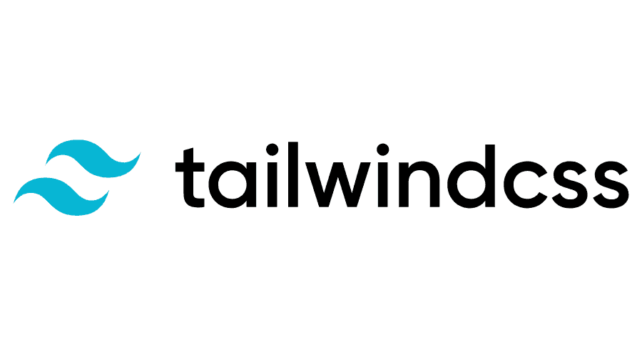  Tailwind CSS | Utility-first styling for consistent layouts with minimal custom CSS.
Charts for dashboards |   Chart.js | Lightweight charting for operational dashboards (counts, queues, aging/time-in-stage).
Backend (API + business rules) |   Node.js + Express.js (REST API) | Minimal backend framework for building API endpoints and implementing routing and process rules.
Authentication |   JWT (RFC 7519; internet standard) | Standard token format for stateless authentication between frontend and API.
Database | 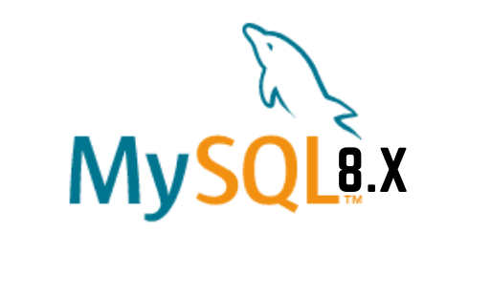  MySQL 8 (InnoDB) | Relational data model with foreign keys for lifecycle, milestones, tasks, and audit logs, enabling consistent reporting queries.
Schema migration and DB access | 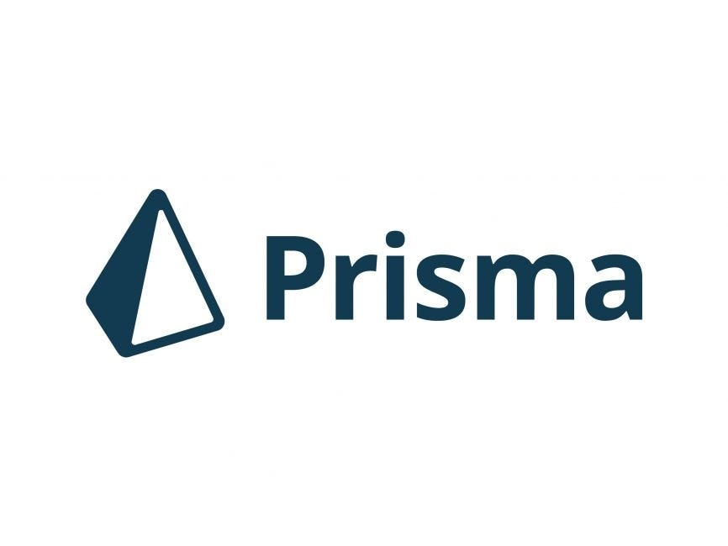  Prisma ORM (migrations + type-safe DB client) | One tool for repeatable schema migrations and type-safe database access, reducing manual SQL drift across sprints.
Project tracking and version control |   GitHub (Repo + Issues/Projects) | Source control and sprint tracking (issues, boards, basic backlog).
Diagrams | 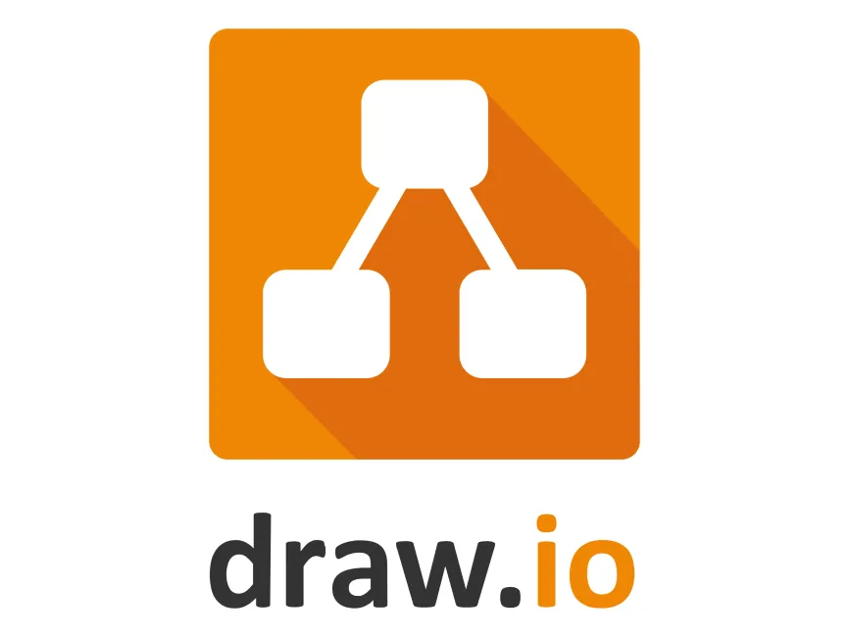  draw.io    dbdiagram.io | Process and architecture diagrams (BPMN, ERD, system diagrams) with a lightweight tool.
Domain and DNS | 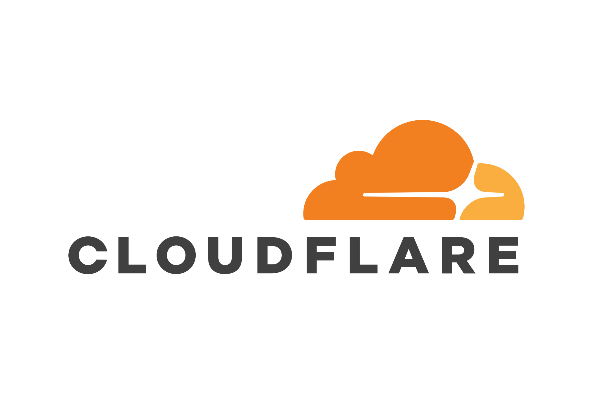  Cloudflare DNS  Cloudflare SSL/TLS  Cloudflare WAF and Firewall Tools  Cloudflare CDN | Manages the system domain/subdomain and DNS records (A/CNAME/TXT) for deployment and verification, with fast updates and centralized control
HTTPS and secure access |  | Provides HTTPS for users and encrypts traffic to the server (Full/Strict), reducing risks from misconfigured SSL on the origin.
Edge security |  | Adds a security layer in front of the server (e.g., basic filtering, rate limiting, DDoS protection) to reduce direct exposure of the origin.
Performance |  | Caches static assets to improve load time and reduce load on the origin server during peak access or demos.
RAG orchestration |   LangChain.js | Handles document chunking, retrieval flow, and prompt grounding for the assistant.
Embeddings and language model | 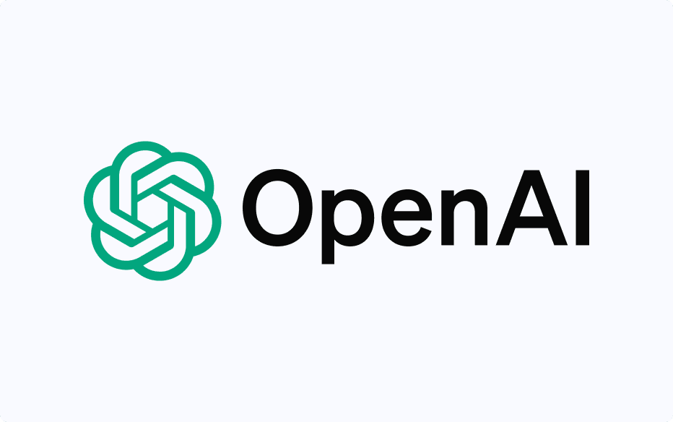  GPT-4.1 LLM | Generates embeddings for retrieval and grounded responses for policy and case guidance.
Vector database |   ChromaDB | Stores indexed document embeddings and supports similarity-based retrieval of policy and case references.
Policy and case guidance | RAG Pipeline | Retrieves approved documents first, then generates grounded summaries, guidance, and suggested next steps for administrative support.

Table 9. IT tools to be used

3.2.5.2 Platform Approach
The platform will be implemented as a web application with a simple three-layer structure:
- Presentation layer: React + TypeScript UI (dashboards, queues, forms)
- Service layer: Node.js + Express REST API for process rules, routing, and audit events
- Data layer: MySQL 8 relational database using InnoDB foreign keys for integrity; Prisma for schema migrations
This supports incremental delivery while ensuring monitoring outputs are derived from event history and timestamps, not only from manually maintained “current status” fields.

3.2.5.3 Database and Reporting
- MySQL 8 (InnoDB) stores structured entities such as Student, MilestoneEvent, TaskQueue, SchedulingEvent, DocumentArtifact metadata, Alert, and AuditLog. Foreign keys are used to keep linked records consistent.
- Dashboards and reports are computed using SQL queries and views (counts per stage, pending queues, aging/time-in-stage, LOA visibility, scheduling cycle time). Chart.js renders the results on the UI.
This approach remains scalable because reporting is based on indexed, timestamped events and relational joins, which are stable patterns for operational monitoring.

3.2.5.4 Prescriptive Analysis for Decision Support
Prescriptive decision support will be implemented as rule-based recommendations computed in the backend from confirmed events, timestamps, ownership assignments, evidence checklist status, and policy-confirmed parameters. These recommendations are not based on free-form interpretation alone. Instead, recommendations are produced from structured monitoring records and defined process logic. Examples include prompts such as “case exceeded allowed time-in-stage, escalate to coordinator,” “required evidence is incomplete, return to the student queue,” or “schedule request has no confirmed outcome, follow up with the assigned role.” The platform does not create, replace, or modify Graduate School policies. It only encodes policy-confirmed rules as decision-support logic.
These rule-based outputs are then made available to the through NotebookLM via Retrieval-Augmented Generation (RAG), which retrieves the computed indicators and related supporting records through approved tools and resources. This allows authorized stakeholders to ask natural-language questions and receive guided summaries, completion rate analysis, next-step prompts, queue prioritization prompts, and escalation prompts based on validated records. Final approvals and official decisions remain with authorized Graduate School personnel.
In this study, the purpose of prescriptive analytics is to reduce repeated manual checking across spreadsheets, protocol forms, and email-based coordination by turning recorded process data into actionable prompts. This directly supports the problem statement of the study, where graduate student status is spread across multiple sources and status confirmation is slow and prone to human error. By computing recommendations from structured records first, and then exposing them through the assistant, the platform improves visibility and follow-through without automating official authority.

3.2.5.5 RAG-Based Decision Support Assistant
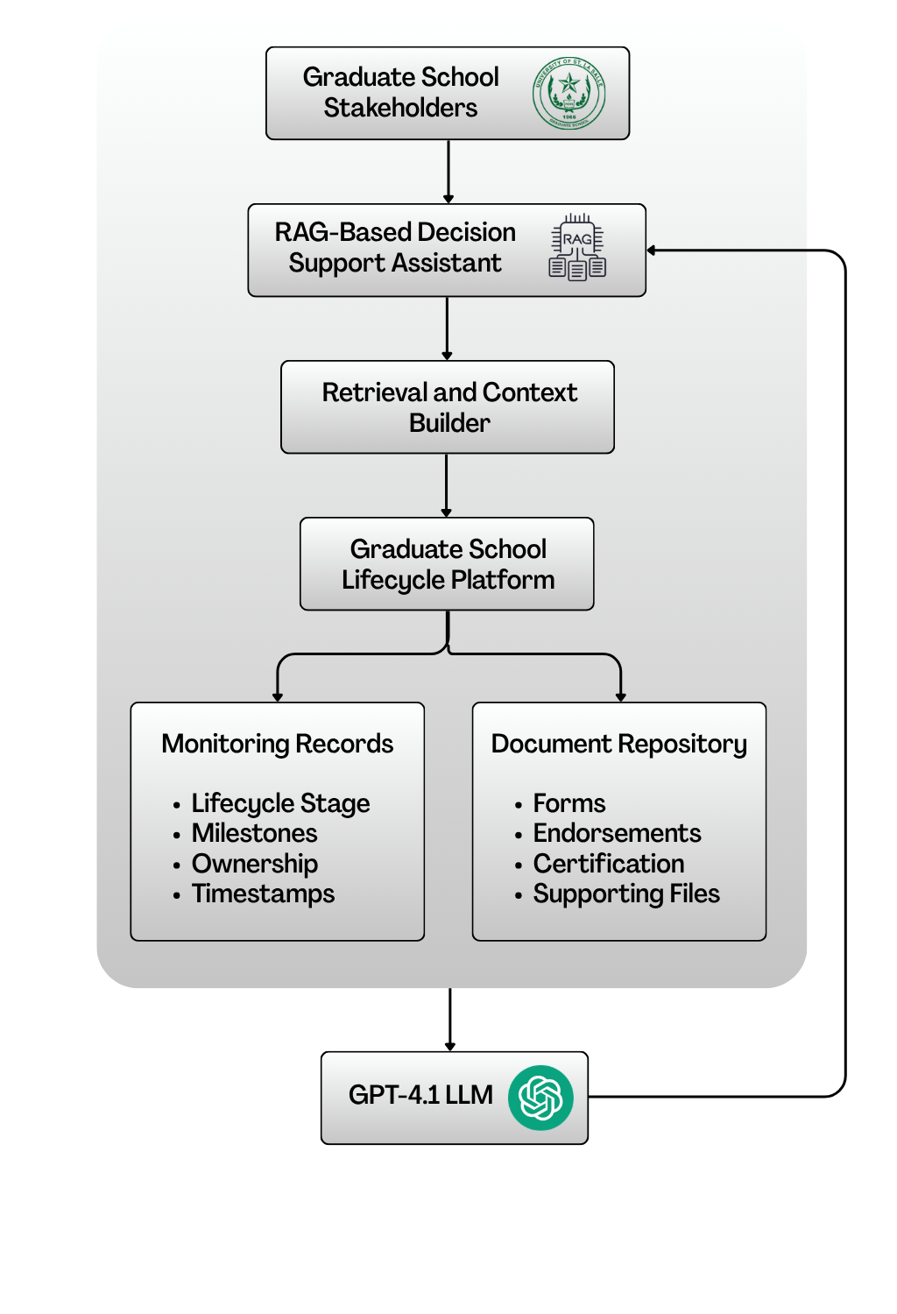

Figure 6. RAG-Based Decision Support Assistant Architecture
This study will use Retrieval-Augmented Generation (RAG) as the grounding approach for the decision support assistant. In this setup, the assistant retrieves relevant Graduate School records and approved reference documents before generating any response. This means the assistant does not rely on free-form guessing or manually maintained status text alone. Instead, it uses retrieved monitoring records, approved document contents, and system-generated indicators as the basis for its answers. This is consistent with the study’s use of RAG through NotebookLM and with the policy-grounded role of the assistant in the proposed platform.
In the proposed platform, the assistant draws from two main input groups. The first is structured operational and monitoring data, such as lifecycle stage, milestone events, ownership assignments, scheduling records, timestamps, checklist completion, and decision outcomes. The second is the approved repository of uploaded forms and documents collected throughout the Graduate School process, such as protocol forms, endorsements, comments, certifications, supporting files, and policy references. The retrieved materials are then used as context for the assistant’s response.
The assistant does not compute official status by itself. Official monitoring signals and prescriptive indicators are still computed first by the system backend and database using validated event history, timestamps, checklist rules, and policy-confirmed process logic. These computed results may include the current lifecycle stage, pending requirements, latest decision outcome, assigned next-action owner, aging or time-in-stage, overdue tasks, scheduling cycle time, evidence completeness, and completion rates. In this design, the backend remains the source of truth, while RAG serves as the retrieval and explanation layer that helps users access and understand those approved results more easily.
For example, when a stakeholder asks questions such as “What is the status of this student?”, “What is still pending?”, “Who owns the next action?”, or “Which students are delayed?”, the assistant retrieves the relevant monitoring records, computed indicators, and supporting documents before returning a guided summary. For completion rate analysis, the computation is still performed by the backend and database, not by the LLM alone. The completion rate is computed as:
Completion Rate = (Number of completed in-scope cases ÷ Total number of in-scope cases) × 100
A case is treated as completed only when the required exit criteria for the relevant lifecycle stage or milestone have been met based on the milestone gate definitions of the study. Through RAG, the assistant can retrieve these computed rates, grouped counts, and related filters such as program, term, milestone, or cohort, then explain the results in a readable form for stakeholders.
For decision support, the assistant may return guided student status summaries, completion rate summaries, pending requirement lists, next-step prompts, queue prioritization prompts, follow-up reminders, and escalation prompts for delayed cases. These outputs are for decision support only. The assistant does not automate approvals, override Graduate School authority, or change official policies. Final decisions remain with authorized personnel such as Graduate School staff, coordinators, advisers, panel members, and the Dean. This is aligned with the study’s positioning of the AI feature as a policy-grounded support tool rather than an autonomous decision maker.
This design directly supports the main problem statement of the study. Since graduate student status is currently spread across multiple sources and status confirmation depends on manual checking and encoding, the RAG-based assistant helps reduce repeated searching across spreadsheets, emails, forms, and separate records. It does this by allowing stakeholders to ask monitoring questions in natural language while still grounding the responses on validated system records, computed indicators, and approved reference documents.

3.2.5.6 Authentication, RBAC, and Audit Logging Tools
Access to information requires strict access control and traceability of actions. The system will implement:
- JWT authentication for UserAccount identities, based on the JWT standard (RFC 7519).
- RBAC authorization is mapped to system roles (staff, coordinator, research coordinator, adviser/panel, student) and scoped by ownership rules where applicable. RBAC enforcement will be validated using security control verification practices aligned with OWASP ASVS.
- Append-only audit logging (AuditLog table) capturing key events, including decisions, submissions, status transitions, evidence uploads, access attempts, and configuration changes (timestamp, actor, action type, affected record). This supports audit event logging expectations described in NIST SP 800-53.
These controls align with privacy requirements when handling sensitive student records and evaluation artifacts (Datu, 2022; Doce & Ching, 2018; Tanate-Lazo, 2021).

3.2.5.7 Reporting, Dashboards, and Analytics Tools
Dashboards and decision-support outputs will be generated through:
- Application dashboards using SQL aggregation (counts per stage, pending queues, aging/time-in-stage, scheduling cycle time, LOA visibility, workload indicators)
- Exportable reports in CSV and PDF for term-level summaries and endorsement preparation (PDF via printable report views for the prototype)
- A reporting schema or SQL views inside MySQL to standardize definitions and separate operational tables from reporting queries
This aligns with the principle that dashboards are only meaningful when events and timestamps are captured consistently and definitions are aligned (CHED Region IV-B MIMAROPA, 2018; Sorour & Atkins, 2024).

3.2.5.8 Notifications and Alerts Tools
The platform will support basic notification mechanisms for operational follow-through, such as:
- Email notifications using SMTP (for overdue items, LOA expiry reminders, missing evidence, and pending approvals).
- Notification events stored in the database (NotificationAlert records) to preserve traceability (who was notified, when, and why)
- Messages that avoid embedding sensitive content and direct users to log in to the portal for details
Messages will avoid embedding sensitive content and will direct users to log in to the portal for details.

3.2.5.9 Development, Collaboration, and Documentation Tools
To support Agile Scrum delivery and documentation needs, the project will use:
- GitHub for version control (source code, documentation, release tagging) and sprint tracking using Issues and Projects
- Figma for UI wireframes and prototype screens
- diagrams.net (draw.io) for BPMN, ERD, and architecture diagrams
These tools ensure traceability of changes, repeatable testing, and consistent deliverables per sprint.

3.2.6 Database Design
Because the project’s central contribution is monitoring and decision support, the database design prioritizes capturing lifecycle and milestone activity as structured, timestamped events. This avoids relying only on static “current status” fields and reduces inconsistencies from ad hoc spreadsheet updates. The model formalizes existing monitoring signals into related entities that support: (1) traceability (what happened, by whom, and when), (2) accountability routing (who owns the next action), and (3) reporting and prescriptive decision support (counts per stage, pending queues, aging or time-in-stage, scheduling cycle time, and workload visibility).
The model adopts a case-and-event approach. Each student has a profile and program context. Each research engagement is represented as a ResearchCase. Each progression step is recorded as a MilestoneEvent linked to a MilestoneType, including timestamps, decision outcomes, owner roles, and evidence links. Monitoring focuses on submissions, decisions, schedules, and permitted standing or readiness signals, not private adviser–student communication.

3.2.6.1 Core Entities/Tables
Area | Table | Purpose in the system
Identity and Access Management (IAM) | Student | Stores the primary student monitoring identity and program entry context (e.g., cohort/AY entry, program/track).
 | UserAccount | Stores login identities for staff, coordinators, adviser/panel roles, and students (permitted views).
 | Role | Defines system roles used for RBAC.
 | UserRole | Assigns system roles to users (supports RBAC enforcement).
 | AdviserAssignment / PanelAssignment | Links advisers and panel members to students for scoped access and review responsibilities.
Core lifecycle & milestone tracking (monitoring layer) | StudentLifecycle | Stores program/track fields and references to program-dependent settings notes.
 | MilestoneDefinition | Defines milestone requirements by lifecycle stage, expected durations, and criticality.
 | StudentMilestoneStatus | Tracks milestone progress status and due/completion timestamps at the student level.
Process routing & decisions | Task | Represents actionable process items (pending/overdue), ownership, due dates, and recommended next action fields.
 | DecisionLog | Captures decisions made on tasks (approve/revise/return) with decision actor and timestamp.
 | RoutingRule | Defines rule-based routing for next owner roles and follow-up task generation.
Academic lifecycle tracking (monitoring signals) | Program | Stores program/track information and references for program-dependent settings.
 | AcademicTerm | Stores academic year/term identifiers (start/end dates where needed).
 | TermEnrollment | Stores per-term enrollment monitoring signals (confirmation timestamps, allowed status signals).
 | Course | Master list of course code/title/units.
 | CourseEnrollment | Links term enrollment to courses and stores monitoring signals (e.g., in-progress/completed/incomplete markers).
 | Curriculum | Curriculum identifier/version information per program.
 | StudyPlanItem | Stores planned/required subjects per curriculum (and recommended term where applicable).
 | StudentCurriculumTag | Maps a student to a curriculum version/tag (e.g., revised plan/bridging).
Research pipeline tracking (case-and-event) | ResearchCase | Monitoring container for thesis/capstone engagements linked to a student.
 | MilestoneEvent | Records milestone execution as timestamped events (occurredAt, outcome, ownerRole, decision actor, notes) and may reference related process tasks.
Evidence, scheduling, and traceability | DocumentRecord | Stores required-document checklist items per student/milestone, including review status and outstanding revisions count.
 | DocumentVersion | Stores uploaded file versions (file reference, uploadedBy, timestamps) linked to DocumentRecord.
 | RevisionNote | Tracks revision comments/required changes and resolution status linked to DocumentRecord and/or DocumentVersion.
 | ScheduleRequest | Stores scheduling requests tied to a student (requestedBy, preferred dates, status).
 | Availability | Collects availability windows from users for a ScheduleRequest.
 | ScheduleEvent | Stores schedule outcomes (confirmed/rescheduled/cancelled) with timestamps and decision actor.
 | FormSubmission | Tracks protocol-driven forms with submitted/endorsed/approved timestamps and routing state.
 | ClearanceRecord | Tracks clearance submission/outcome dates where applicable.
 | TimelineEvent | Provides a consolidated “what happened” feed by recording key events and linking to related entities.
Monitoring actions and alerts | AlertThreshold | Stores configured monitoring thresholds (e.g., prolonged stage, delayed scheduling) used by the monitoring engine.
 | NotificationAlert | Logs notifications sent (recipient, reason, timestamp, success metadata).
 | Intervention | Stores follow-up actions with owner, timestamps, and closure evidence.
Auditability | AuditLog | Append-only log of key events (access attempts, decisions, transitions, uploads, configuration changes).

Table 10. Core tables and their purpose

3.2.6.2 Key Relationships and Integrity Rules
Relationship | Meaning | Integrity rule (what must be true)
Student (1) → (many) StudentLifecycle | A student has a stage history (entered/exited timestamps) | StudentLifecycle.StudentID must exist in Student
Student (1) → (many) StudentMilestoneStatus | A student has milestone progress records | StudentMilestoneStatus.StudentID must exist; MilestoneDefinitionID must exist
MilestoneDefinition (1) → (many) StudentMilestoneStatus | Milestone status references a valid milestone | StudentMilestoneStatus.MilestoneDefinitionID must exist
Student (1) → (many) TermEnrollment | A student has per-term monitoring records | TermEnrollment.StudentID must exist; TermEnrollment.TermID must exist
AcademicTerm (1) → (many) TermEnrollment | Enrollment records belong to a term | TermEnrollment.TermID must exist in AcademicTerm
TermEnrollment (1) → (many) CourseEnrollment | Term enrollment can include multiple courses | CourseEnrollment.TermEnrollmentID must exist; CourseEnrollment.CourseID must exist
Course (1) → (many) CourseEnrollment | Course enrollment references valid courses | CourseEnrollment.CourseID must exist in Course
Curriculum (1) → (many) StudyPlanItem | A curriculum defines planned subjects | StudyPlanItem.CurriculumID must exist; StudyPlanItem.CourseID must exist
Student (1) → (many) StudentCurriculumTag | A student can be tagged to a curriculum/version | StudentCurriculumTag.StudentID must exist; CurriculumID must exist
Student (1) → (many) ResearchCase | A student may have a research engagement container | ResearchCase.StudentID must exist
ResearchCase (1) → (many) MilestoneEvent | A case has milestone events over time | If used, MilestoneEvent.ResearchCaseID must exist in ResearchCase
MilestoneDefinition (1) → (many) MilestoneEvent | Events reference valid milestone definitions | MilestoneEvent.MilestoneDefinitionID must exist
Student (1) → (many) DocumentRecord | Document checklist items attach to a student | DocumentRecord.StudentID must exist
DocumentRecord (1) → (many) DocumentVersion | A checklist item can have multiple uploads/versions | DocumentVersion.DocumentRecordID must exist
DocumentRecord (1) → (many) RevisionNote | Revision notes attach to document checklist/version | RevisionNote.DocumentRecordID must exist
Student (1) → (many) ScheduleRequest | Scheduling requests attach to a student | ScheduleRequest.StudentID must exist; Requester must exist
ScheduleRequest (1) → (many) Availability | Availability windows belong to a scheduling request | Availability.ScheduleRequestID must exist; UserID must exist
ScheduleRequest (1) → (many) ScheduleEvent | Schedule outcomes/events belong to a request | ScheduleEvent.ScheduleRequestID must exist
UserAccount/Assignments → Student scope | People are linked to students for scoped access | AdviserAssignment/PanelAssignment.UserID must exist; StudentID must exist

Table 11. Key relationships (high-level PK/FK design)
Validation Rules:
- A MilestoneEvent should not be recorded as “completed/approved” unless required fields are present (timestamp, outcome, confirming role/actor) and required evidence checklist items (DocumentRecord status) are satisfied where applicable.
- A Task should not be closed without a corresponding DecisionLog entry that records decision outcome and decision actor.
- DocumentVersion should enforce version consistency (e.g., only one “current” version per DocumentRecord, if implemented), and revision notes should be traceable to a document record/version.
- A ScheduleEvent should not be marked “confirmed” unless the scheduled date/time (scheduledAt) and decision actor (decidedById) are captured.
- AuditLog entries are created for every decision, lifecycle stage transition, evidence upload, access attempt (success/denied), and configuration change.

3.2.6.3 Entity-Relationship Diagram (ERD) and Table Group Overview

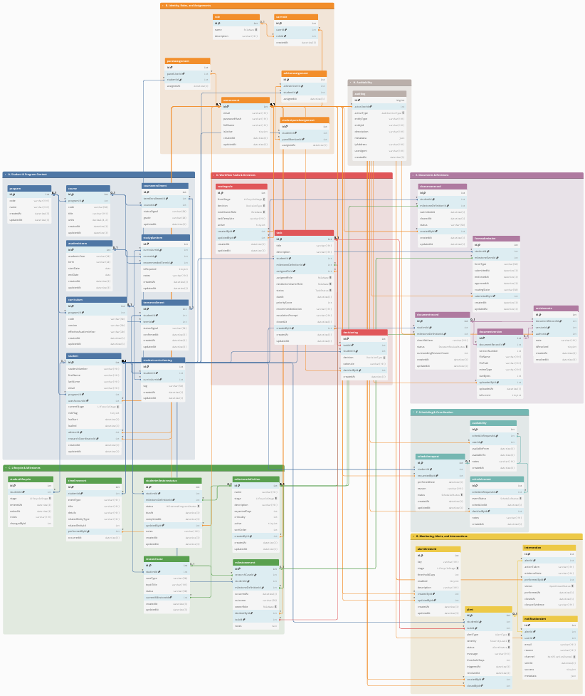

Figure 7. Full ERD of the proposed platform database (grouped)
Figure 7 presents the full ERD of the proposed database. For readability, the ERD is organized into functional groups (A to H). Figures X.1 to X.8 show cropped views of each group. Each caption highlights only the key tables and connections needed for monitoring and decision support.
A. Student and Program Context
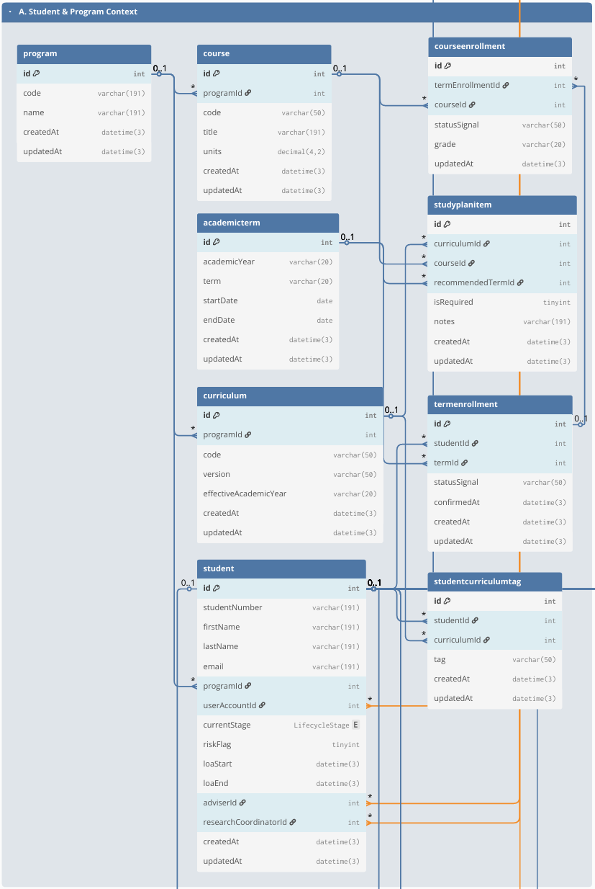

Figure 7.1 Group A. Student and Program Context
This group stores the core student monitoring identity and the student’s program context (Student, Program). Student serves as the primary reference across the database and links to academic monitoring (term/course records), lifecycle/milestone tracking, process tasks, documents, scheduling, alerts, and audit logs. Program provides the program/track context used for filtering, reporting, and program-dependent settings.
B. Identity, Roles, and Assignments

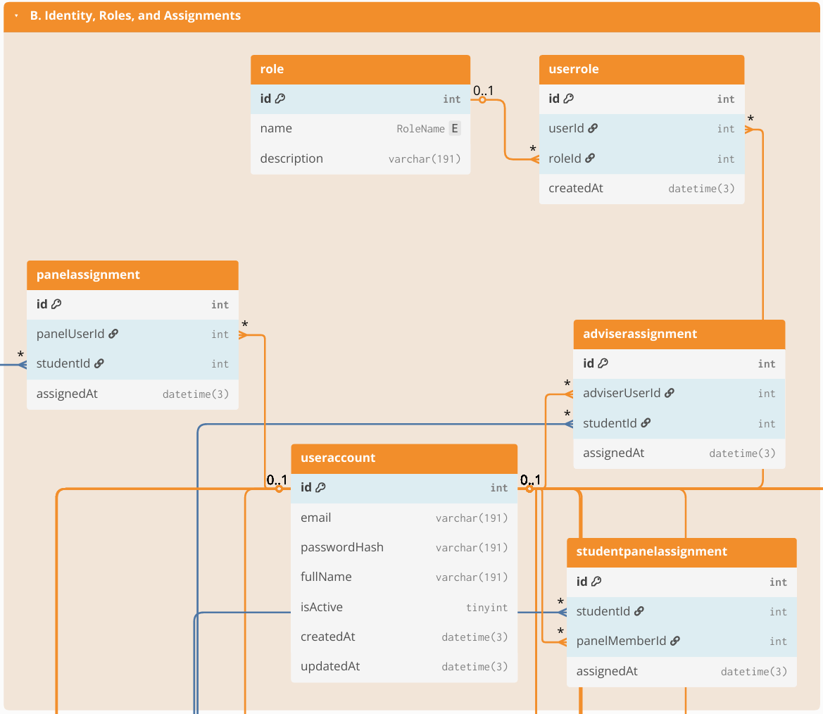

Figure 7.2 Group B. Identity, Roles, and Assignments
This group defines system accounts and role-based access control structures (UserAccount, Role, UserRole), and the scoped assignments that determine which students a user may access (e.g., AdviserAssignment, PanelAssignment, or equivalent assignment tables used by the system). These links enforce privacy boundaries (who can see which student/case) and support operational routing by clarifying who participates in review handoffs (coordinator/adviser/panel) without relying on informal messaging.
C. Lifecycle & Milestones

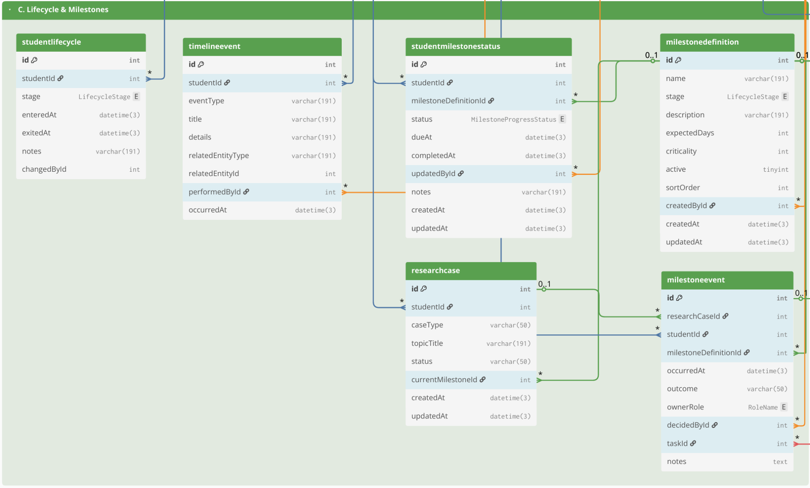Figure 7.3 Group C. Lifecycle & Milestones
This group provides the monitoring backbone for student standing and progress through lifecycle stages and requirements. It includes lifecycle stage history and milestone definitions (StudentLifecycle, MilestoneDefinition, StudentMilestoneStatus) and may also include the academic monitoring layer (AcademicTerm, TermEnrollment, CourseEnrollment, Course, Curriculum, StudyPlanItem, StudentCurriculumTag) when those signals are needed to support readiness views. The emphasis is on timestamped progress indicators (entered/exited stage, due/completion markers) that enable time-in-stage and overdue tracking.

D. Workflow Tasks & Decisions

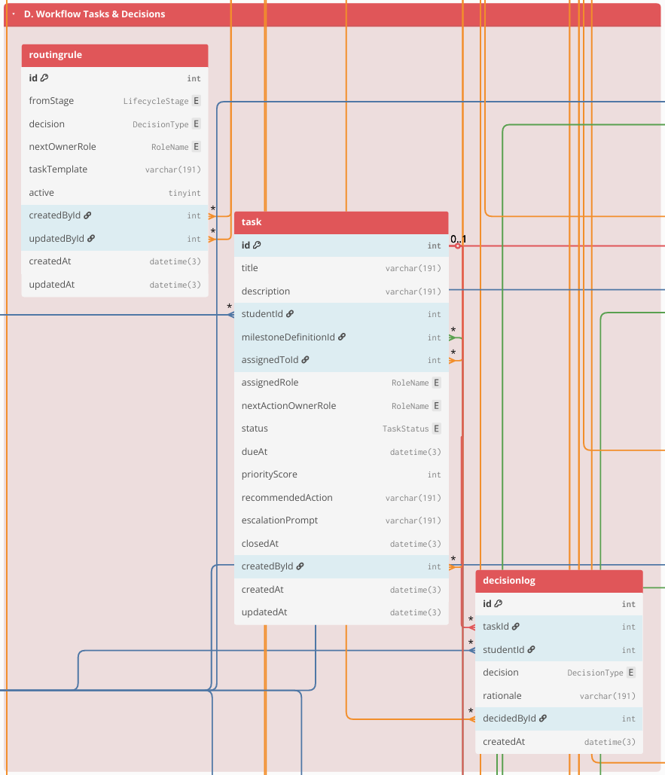

Figure 7.4 Group D. Workflow Tasks & Decisions
This group represents the operational “work queue” of the Graduate School. Workflow items are stored as Task records (owner, due date, priority/recommendations), and decisions are recorded as structured outcomes in DecisionLog (approve/revise/return), with routing rules handled through RoutingRule (or equivalent). Where the case-and-event approach is implemented, a student’s research engagement can be represented as ResearchCase, and milestone completion can be recorded as MilestoneEvent entries linked to tasks/decisions. This structure supports accountability (“who owns the next action”) and consistent decision traceability.
E. Documents & Revisions

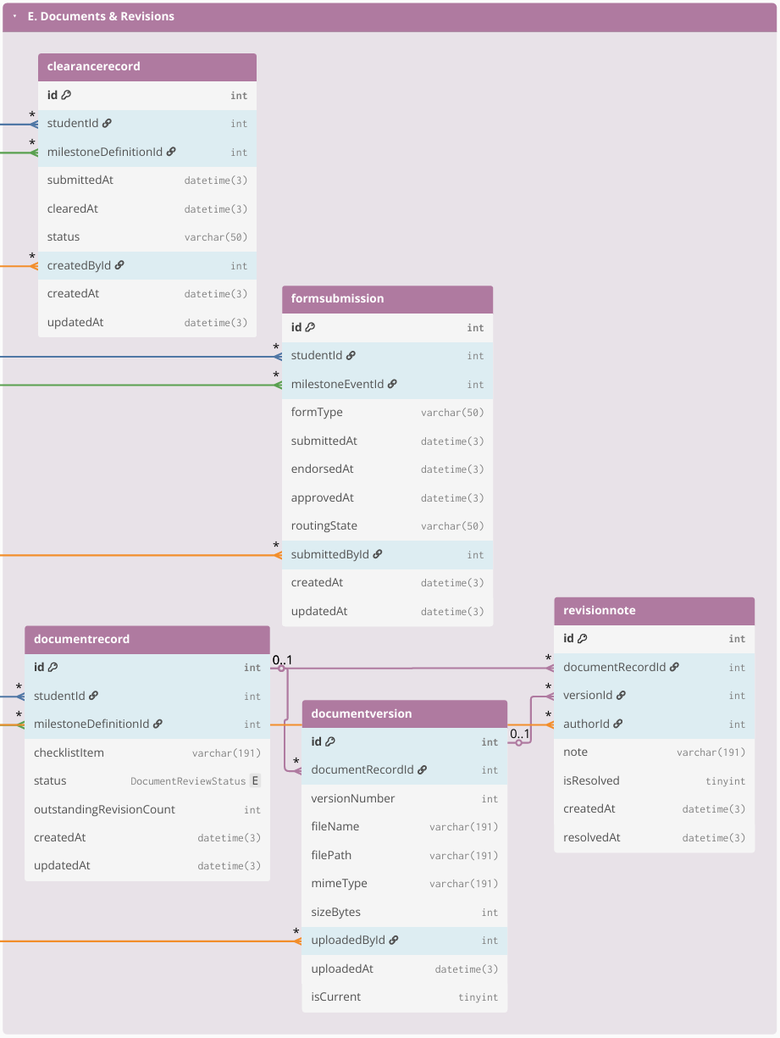

Figure 7.5 Group E. Documents & Revisions
This group stores evidence and version traceability for required submissions. Document requirements are represented through checklist-style records (DocumentRecord) and their uploaded versions (DocumentVersion), with revision and compliance tracking handled through RevisionNote (and status fields such as resolved/reopened). Where applicable, protocol-driven requirements and clearances are captured through FormSubmission and ClearanceRecord. The purpose is to keep a single, auditable reference for “what version was submitted,” “what revisions were required,” and “what is still pending.”
F. Scheduling & Coordination
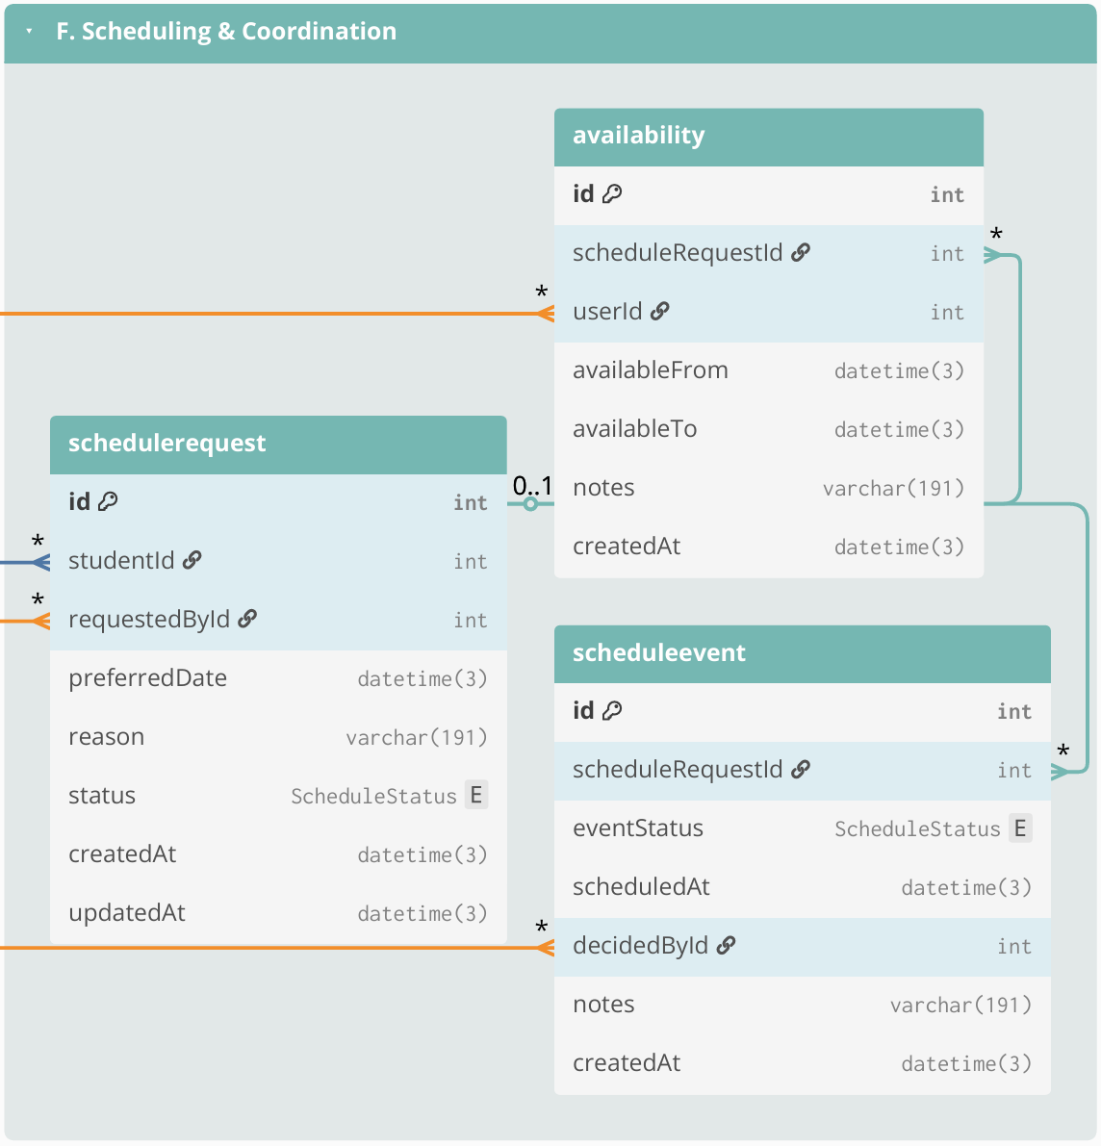

Figure 7.6 Group F. Scheduling & Coordination
This group manages scheduling process related to milestone activities (e.g., defenses and evaluations). Scheduling is stored using ScheduleRequest (request context and status), Availability (submitted availability windows), and ScheduleEvent (confirmed/rescheduled/cancelled outcomes with timestamps and decision actors). These records support scheduling cycle-time reporting and reduce back-and-forth coordination through email/chat by consolidating scheduling history in one place.
G. Monitoring, Alerts, and Interventions

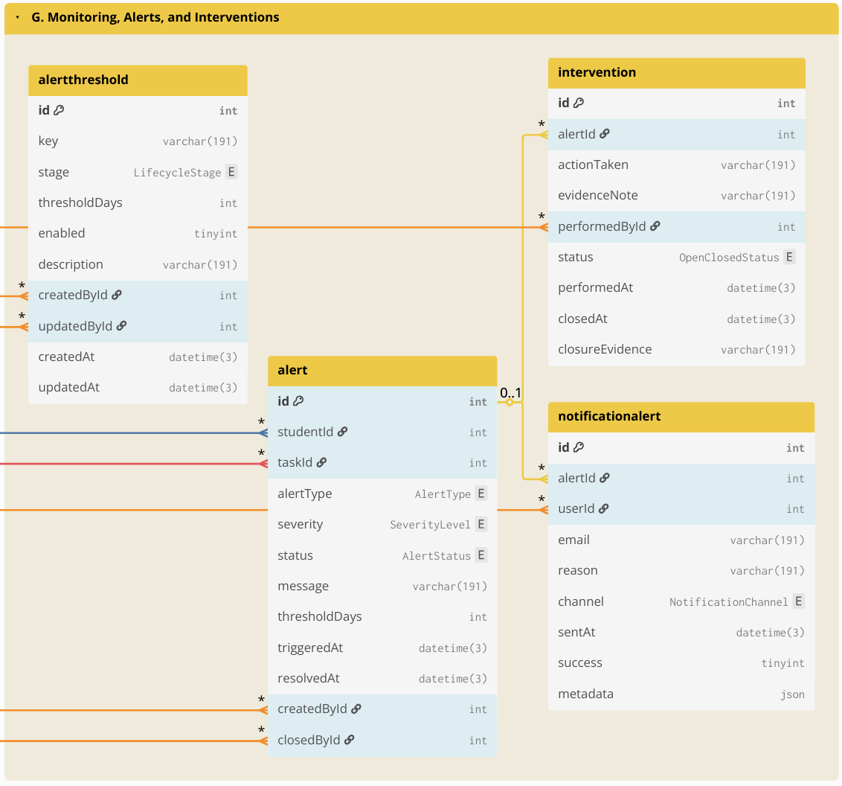

Figure 7.7 Group G. Monitoring, Alerts, and Interventions
This group supports proactive operational monitoring by turning derived indicators into actionable flags and follow-ups. Thresholds and rules may be stored in AlertThreshold (or equivalent), which are evaluated against timestamped monitoring signals (time-in-stage, overdue tasks, inactivity, delayed scheduling). Results are stored as Alert (or alert records) and notifications as NotificationAlert (who was notified, when, and why), while follow-up actions are tracked through Intervention (owner, due date, closure evidence/date). This enables early identification of delayed cases and operational follow-through.
H. Auditability
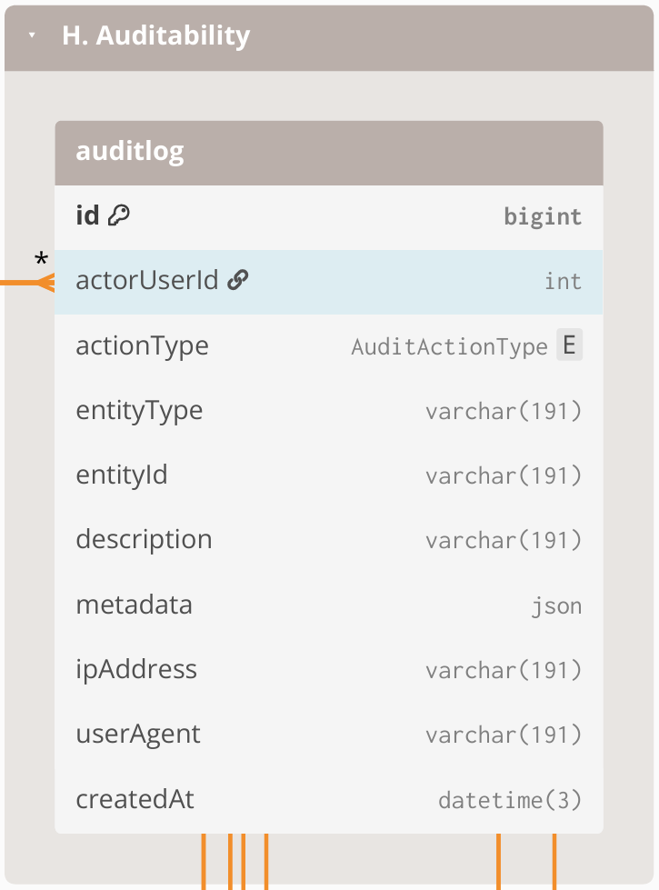

Figure 7.8 Group H. Auditability
This group provides accountability and traceability across the entire system. AuditLog is maintained as an append-only record of key events such as login/access attempts (including denied access), lifecycle transitions, task decisions, evidence uploads, scheduling outcomes, configuration changes, and notifications. Audit entries link to the acting user and store the affected record reference (entity type + entity ID), enabling traceability without requiring foreign keys from AuditLog to every table.

3.2.6.4 Computed Indicators for Prescriptive Analytics and Decision Support
To support descriptive monitoring and prescriptive decision support, operational data is transformed into computed indicators based on event history, timestamps, ownership assignments, decision outcomes, and evidence checklist status. These indicators serve as the system-generated inputs for prescriptive analytics and decision support. The computed indicators support (1) dashboards and monitoring views, such as counts per stage, pending queues, and aging or time-in-stage, and (2) rule-based recommendations such as queue prioritization, follow-up prompts, and escalation triggers. These indicators are computed from recorded events and completeness checks rather than from manually edited “current status” fields.
Computed indicator | Computed from | Decision-support use (how it drives prescriptive actions)
Current stage or milestone position | Latest MilestoneEvent per ResearchCase + MilestoneType ordering/definitions | Identifies where the case is now and which next action is relevant
Pending queue membership | MilestoneEvent with incomplete outcome + RoleAssignment owner + due date rules (if applicable) | Places cases into the correct role-based queue and enables prioritization
Aging or time-in-stage | Date difference between “now” and last MilestoneEvent timestamp, or between milestone timestamps | Flags stalled cases; triggers follow-up prompts and escalation when thresholds are reached
Overdue tasks and SLA breaches | Task due date (from process rules) vs current date + completion state | Generates “overdue” labels; recommends urgent follow-up or escalation
Scheduling cycle time | DefenseEvent request date to confirmed schedule date; reschedule count | Detects scheduling delays; recommends next coordination step and highlights repeated reschedules
Evidence completeness score | Required evidence checklist vs DocumentArtifact links for the milestone | Blocks completion when required evidence is missing; recommends what document to request
Decision outcome state | Latest decision outcome in MilestoneEvent (approve, revise, return) | Determines the next routing step; recommends who should act next
Prescriptive recommendation output | Rule-based checks applied to indicators above using policy-confirmed parameters | Produces recommended next actions, queue prioritization, and escalation prompts without automating final approvals

Table 13. Computed indicators from event history used for prescriptive analytics and decision support
This table shows that prescriptive analytics and decision support are based on system-generated indicators computed from timestamped events, ownership records, decision outcomes, and evidence completeness, rather than on manually maintained status fields. These computed indicators also serve as the structured inputs exposed for the Retrieval-Augmented Generation (RAG) through NotebookLM, so stakeholder-facing status explanations, completion rate analysis, and next-step prompts remain grounded on validated records and policy-confirmed logic.

3.2.6.5 Resource Planning
This subsection presents the resource requirements for implementing the proposed Graduate Student Lifecycle Monitoring and Analytics Platform. Since the Graduate School has a relatively small user population (approximately 400-500 students + staff) and the software stack is primarily open-source, the minimum cost of implementation can be kept low by leveraging existing school infrastructure. The major cost drivers are infrastructure availability (server and storage), routine system maintenance, and backup procedures. The following table summarizes the minimum resource requirements assuming existing campus resources, as well as the potential costs if additional resources are needed.
ON-SITE (On-Premises using existing infrastructure)
Item | Type | Cost | Potential Costs (if not existing) | Notes
Server hardware | One-time | ₱0 | ₱7,000–₱50,000 | Use an existing campus machine. Modest specs can support an MVP for a small graduate school with low concurrent usage.
OS + software stack | One-time | ₱0 | ₱0 | Open-source tools; no licensing fees.
HTTPS / SSL certificate | Annual | ₱0 | ₱0–₱5,000 | Free SSL via Let’s Encrypt; paid certificate optional depending on institutional policy.
Domain / subdomain | Annual | ₱0 | ₱800–₱1,500 | If USLS provides a subdomain under an existing domain, no additional cost.
Backups (storage + retention) | Monthly | ₱0 | ₱500–₱2,000 | Applies only if additional backup media/storage allocation or offsite copying is required.
IT operations (maintenance and support) | Monthly | ₱0 | Variable if there is an IT staff. | Patching, monitoring, user support, access management; typically absorbed by existing IT workload.
Email notification service (SMTP) | Monthly | ₱0 | ₱0–₱500 | Can use existing school email relay; external relay is optional for MVP use.
LLM API | Monthly/usage-based | ₱0 | ₱100–₱500 | Estimated for light MVP use only. If enabled, the LLM is used only for advisory outputs such as policy-grounded summaries, completion rate analysis, and next-step prompts. Official OpenAI pricing for GPT-4.1 is $2.00 per 1M input tokens, $0.50 per 1M cached input tokens, and $8.00 per 1M output tokens. Using a BSP reference rate of about ₱60.30 per US$1, this is roughly ₱120.60 per 1M input tokens, ₱30.15 per 1M cached input tokens, and ₱482.40 per 1M output tokens. A light MVP workload can reasonably stay around ₱100–₱400 per month, depending on prompt volume, retrieved context size, and output length.

Table 14. Cost table for on-site premises
This table summarizes the minimum (low-cost) resources required to deploy the platform either on-site (on-premises using existing campus infrastructure) and lists potential costs only when additional services are needed.
To minimize cost, the school may deploy the platform within the campus network using existing infrastructure. The minimum operational requirements are: (1) a stable host machine for the web application and database, (2) secured access controls (role-based access control and audit trail), and (3) backup and recovery procedures.
AI-assisted prescriptive recommendations, the system can operate fully without AI by keeping the feature flag disabled. If enabled, AI remains advisory only (no automatic decisions) and should only process aggregated, de-identified indicators. If the school wants zero additional cost and zero external processing, the AI feature remains OFF.

3.3 Workplan
This section presents the work timeline and sprint plan for the development of the Graduate Student Lifecycle Monitoring and Analytics Platform for the University of St. La Salle Graduate School. The workplan is divided into CAP-IT1 (primary build and internal validation) and CAP-IT2 (remaining refinements, stakeholder evaluation, and final packaging). CAP-IT1 carries the majority of implementation work, while CAP-IT2 focuses on evaluation-driven refinements and completion activities.

3.3.1 Target Accomplishment for CAP-IT1 (80% of IT development)
During CAP-IT1, the proponents aim to complete the main build of the proposed Graduate Student Lifecycle Monitoring and Analytics Platform. This phase will cover the primary implementation of the core platform, including user and access management, lifecycle and milestone management, workflow routing and decision tracking, document and revision management, scheduling and coordination, monitoring and alerts, analytics and reporting, and audit logging. By the end of CAP-IT1, the goal is to deliver an end-to-end working MVP with the main user interface, database, backend logic, and core module integrations already functioning. Initial testing and internal validation will also be conducted to confirm that the major monitoring, processing, and reporting features are already usable. This matches the workplan where CAP-IT1 is treated as the primary implementation phase for the system MVP.

3.3.2 Target Accomplishment for CAP-IT2 (20% of IT development)
During CAP-IT2, the proponents aim to complete the remaining 20% of the project through stakeholder evaluation, refinement, and final system improvement. This phase will focus on usability testing, user acceptance testing, workflow and dashboard refinements, access control and audit hardening, reporting polish, and final documentation and deployment preparation. In this phase, the proponents may also complete the limited prototype-level integration of the RAG-based policy and case guidance feature to support grounded policy and case interpretation, without making it the main implementation focus of the system. By the end of CAP-IT2, the goal is to deliver a more polished, validated, and defense-ready version of the platform. This follows the revised workplan, where CAP-IT2 is focused more on completion, refinement, and packaging rather than introducing new major modules.

3.3.3 CAP-IT1 Work Timeline
Development |  |  | May |  |  |  | Jun |  |  |  |  | Jul |  |  |  | Aug
# | Module | Activities | 4 | 11 | 18 | 25 | 1 | 8 | 15 | 22 | 29 | 6 | 13 | 20 | 27 | 3
1 | User & Access Management | Design role-based access interface (login, role dashboards)
 |  | Design RBAC database schema (users, roles, permissions)
 |  | Develop authentication and authorization prototype
 |  | Implement authentication logic, role-permission enforcement, and access validation rules
 |  | Conduct access testing
 |  | Sprint review and RBAC validation with stakeholders
2 | Lifecycle & Milestone Management | Design lifecycle stage interface
 |  | Design lifecycle database structure (stages, milestones, timestamps)
 |  | Prototype stage transition logic and milestone prerequisite checks
 |  | Implement lifecycle progression engine
 |  | Test stage gating and timestamp logging accuracy
 |  | Sprint review of lifecycle logic and milestone flow
3 | Workflow Routing & Decision Management | Design structured workflow queue interface
 |  | Design decision log and routing database schema
 |  | Prototype approve/revise/return decision pathways
 |  | Implement workflow routing engine and ownership reassignment
 |  | Conduct traceability and decision integrity testing
 |  | Sprint review on workflow clarity and ownership visibility
4 | Document & Revision Management | Design checklist and document submission interface
 |  | Design document metadata schema
 |  | Prototype document submission and revision tracking flow
 |  | Implement revision logging and checklist validation engine
 |  | Conduct version traceability testing
 |  | Sprint review of document tracking accuracy
5 | Scheduling & Coordination Management | Design scheduling request and availability interface
 |  | Design scheduling database
 |  | Prototype defense scheduling logic
 |  | Implement scheduling coordination engine
 |  | Conduct scheduling validation & sprint review
6 | Monitoring, Alerts & Intervention Engine | Design monitoring dashboard interface (risk indicators & alert views)
 |  | Design monitoring database logic (threshold rules, time-in-stage computation, escalation mapping)
 |  | Prototype automated alert detection logic
 |  | Implement monitoring and escalation engine (threshold evaluation + intervention logging)
 |  | Conduct alert accuracy testing (threshold validation & false-positive checks)
 |  | Sprint review of intervention logging and escalation clarity
7 | Analytics & Reporting | Design analytics dashboard layout (queue aging, bottleneck views, load metrics)
 |  | Design analytics aggregation schema reporting mart tables & computed metrics)
 |  | Implement reporting queries and dashboard visualizations
 |  | Conduct analytics validation testing (metric accuracy, aggregation consistency, cross-module data integrity)
 |  | Sprint review on reporting accuracy
8 | Database Audit | Design audit trail interface (activity log viewer & filtering tools)
 |  | Design append-only audit log schema (action logs, timestamp mapping, user-action trace)
 |  | Implement cross-module activity logging integration
 |  | Conduct audit integrity testing (log completeness, tamper resistance validation)
 |  | Sprint review on traceability coverage

Table 15.1. CAP-IT1 Work Timeline (80% target)
Table 15.1 outlines CAP-IT1 as the primary implementation phase where the system’s core modules are developed into an MVP. Modules correspond to the major components of the proposed lifecycle monitoring platform (e.g., core platform/RBAC, curriculum & study plan, enrollment/course audit, thesis/dissertation pipeline tracking, workflow routing and queues, evidence/document management, scheduling/LOA tracking, dashboards and audit logs), and analytics/reporting. Each sprint follows a consistent activity sequence (design → coding → testing → stakeholder feedback) to support iterative delivery.

3.3.4 CAP-IT2 Work Timeline
Development |  |  | Aug |  | Sep |  |  |  | Oct |  |  |  | Nov
# | Module | Activities | 24 | 31 | 7 | 14 | 21 | 28 | 5 | 12 | 19 | 26 | 2 | 9 | 16 | 23
9 | Evaluation Setup | Design structured usability and monitoring-interpretation evaluation instruments
 |  | Conduct pilot evaluation session
 |  | Finalize evaluation protocol for stakeholder sessions
10 | Stakeholder Usability / UAT | Conduct structured UAT Session 1 (Lifecycle tracking, Workflow routing validation)
Conduct structured UAT Session 2
(Monitoring alerts, Analytics dashboards, Access Control or Audit validation)
Consolidate findings
Document usability gaps and interpretation inconsistencies
11 | Refinements (Iteration 1) | Implement UI clarity improvements (dashboard readability, queue labeling, milestone visualization)
 |  | Refine workflow routing flows and decision-state clarity
Conduct full regression testing across Modules 1–8
(ensure refinements did not break monitoring, analytics, or access control logic)
12 | Access Control or Audit Hardening | RBAC scoping improvements
 |  | Audit log coverage + integrity checks
 |  | Regression testing
13 | Reporting & Export Polish | Access Control or Audit Hardening
Finalize export formats and endorsement-ready reporting outputs
(PDF/CSV exports, summary report structure validation)
14 | Documentation Finalization | Integrate final implementation updates into Chapter 3 & Chapter 4
 |  | Finalize User Guide and Admin Guide documentation
 |  | Clean appendix materials (BPMN, ERD, tables, architecture diagrams)
15 | Final Demo + Defense Prep | Package final build for deployment demonstration
 |  | Conduct final defense rehearsal and structured system walkthrough

Table 15.2. CAP-IT2 Work Timeline (20% target)
Table 15.2 outlines CAP-IT2 as the completion phase focused on stakeholder evaluation, refinement, and final packaging. Activities prioritize usability testing, validation of gate criteria and monitoring interpretations, RBAC/audit hardening, reporting polish, documentation finalization, and final defense readiness. CAP-IT2 intentionally concentrates on improving accuracy, interpretability, and stakeholder acceptability rather than introducing new major modules.

